Our Lambda Iota Chapter continues to be a leading fraternity at Purdue University. Founded in 1902, the chapter has initiated over 1,900 brothers, with more than 1,560 of them still living.

Indeed, our greatest asset is our band of brothers. And while we graduate brothers enjoy the continuing benefits of our extensive Fiji network, a most basic element of our brotherhood is our ever-increasing number of undergraduate brothers. We are proud of the young men currently in our chapter:

* 29 new members were initiated under the new four-day pledge program as directed by National Headquarters. This included nine legacies. The new class of 2028 had a semester GPA of 3.21.
* The house GPA last semester was 3.26 placing us 9th overall, above the all men’s average and more importantly 5th among fraternities of over 100 members.
* The house had the highest philanthropy in history aided by the $28,000 raised in the Run the Football event done in conjunction with IU. Members performed 422 community service hours. Truly Lambda Iota is giving back.
* Liam Bettez (2021) was a recipient of the Phi Gamma Delta Wilkinson Award, which is a nationwide award recognizing the fraternity’s most outstanding graduating senior.

For additional information about the chapter today, please see the issues of the ***Russell Street Review*** found on the chapter website, www.purduefiji.com.

The Future of Fraternities – Nationally and at Purdue

Interested brothers are surely aware of a number of nationally publicized incidents of hazing and alcohol abuse in various fraternities, including certain Fiji chapters, which have tragically resulted in personal injuries and a few fatalities. Insurance carriers are now demanding national fraternities and local chapters to change to reduce and avoid such risky practices, and they are adding further limitations and exclusions to certain liability coverages. Our International Fraternity has acted to adopt changes to our fraternity’s joining process that significantly reduce the dynamics that can contribute to an environment in which hazing may arise, and better position our fraternity for the future.

Purdue University continues to host a vibrant Greek community comprising more than 80 fraternities and sororities, which provide the West Lafayette campus housing for about 4,000 undergraduate students. Since January 2016, our International Fraternity has focused our brotherhood on “Building Courageous Leaders,” emphasizing the core values of our fraternity, scholarship, and risk management education, including preventing hazing and alcohol and sexual misconduct. Our August 2022 Ekklesia adopted amendments to Phi Gamma Delta’s Constitution and By-Laws similar to changes successfully adopted in recent years by numerous other national fraternities. Our fraternity’s chapters are now encouraged to adopt more rigorous and lengthy rush programs to facilitate better evaluation of candidates prior to an invitation to join. Effective immediately, the pledge period may last only four weeks. And effective July 1, 2024, new brothers will be initiated within four days of acceptance of a chapter invitation, thereby eliminating the pledge period as we have known it.

These changes are a springboard for a modernized recruitment and assimilation process, whereby chapters reduce their reliance on a short-term “rush” process and adopt a comprehensive four-year member education framework to better develop and engage undergraduates. Our undergraduate and graduate chapter leaders are busy finalizing a plan to adapt Lambda Iota traditions and customs into the framework provided by our International Fraternity. These constructive changes will provide a sound substantive basis for a long and bright future for Phi Gamma Delta and our Lambda Iota chapter at Purdue.

The Challenge for Lambda Iota

Our single most important tangible asset is the chapter house at 640 Russell Street. As an important piece of the recruitment process, the maintenance and improvement of our house provide a vital and necessary foundation supporting our undergraduate brothers.

The University continues to build 21st-century dormitories which feature state-of-the-art facilities. Quite a few of our competitors in the Greek system have completed renovations and enhancements to their living accommodations in the last ten years, and private landlords are building more sophisticated apartment options off-campus. It is very important to note that Purdue University remains supportive of the Greek system.

Located near classrooms, sports venues, and recreational resources, 640 Russell is an extremely favorable location. And we intend to be there for a very long time! We do, however, face challenges with the physical structure of the chapter house, including increasing maintenance costs and routine system repair and replacement, and the quality and amount of space per occupant, which is inferior to that available in other fraternities and in university housing.

Originally built in 1926, much work has been done to our home over its almost 100-year history, including a major infrastructure update and upgrade several years ago. In that recent Phase 1 effort, we completed the following:

1. Purchased two lots to the South, making a house addition possible ($1.3 million).
2. Leased 15 parking spaces from the University; this provides sufficient parking required by zoning for an addition.
3. Engaged an architect and produced drawings for renovation, expansion, and parking at a cost of $500,000.
4. Engaged a law firm to maximize educational space to get the best possible tax deductibility of future contributions.
5. Completed all borings, permitting, and licensing to purchase land.
6. Developed a reconfigured floor plan for the existing house to provide more floor and closet space per occupant.
7. Replaced hot water radiator heat with new HVAC, thus providing air conditioning for the historic house.
8. Installed a new hot water system for the entire house.
9. Completely gutted and replaced the men’s restrooms on the 2nd and 3rd floors and the ladies’ powder room on the 1st floor.
10. Installed new fresh water and wastewater plumbing to restrooms.
11. Replaced rotten joists and subfloors in restrooms.
12. Reinforced floors in the dining room, vestibule, and room 21.
13. Replaced electrical feed and switch box with substantially larger capacity.
14. Corrected non-conforming gutter water flow to city utilities.
15. Reconstructed the courtyard to eliminate clutter and drainage issues.

Though not all of these steps are visible to residents and visitors, they were all necessary. Yet, even with the completion of these items in Phase I, the challenge is clear: solidify the future of Phi Gamma Delta at Purdue University.

To remain a competitive option in the Greek system, we must be financially able to handle the ebbs and flows of chapter membership, the ongoing maintenance and capital needs of our chapter house, and offer a home that is safe and an attractive housing option when evaluated against the expanded dorm offerings provided by the university, off-campus housing options, and especially the significant improvements made to other fraternity houses which may make our aging chapter home less appealing to prospective members.

The Next Phase

The Lambda Iota Graduate Corporation is beginning **Phase 2** to raise funds for the following priorities, which, collectively, will ensure the continuation of and the legacy of Lambda Iota for future generations of young men:

* **Chapter House Addition** – ensuring that our chapter house is an attractive living option in today’s competitive marketplace
* **Expanded Space Per Occupant** – after the addition is completed, the plan includes reconfiguring some walls in the existing house to provide more floor space per occupant
* **Financial Security** – ensuring a financially independent, long-term future for Lambda Iota
* **Chapter House Maintenance Fund** – ensuring timely completion of routine maintenance and systems replacement

Following are artist’s renderings of the Phase 2 extended chapter house:

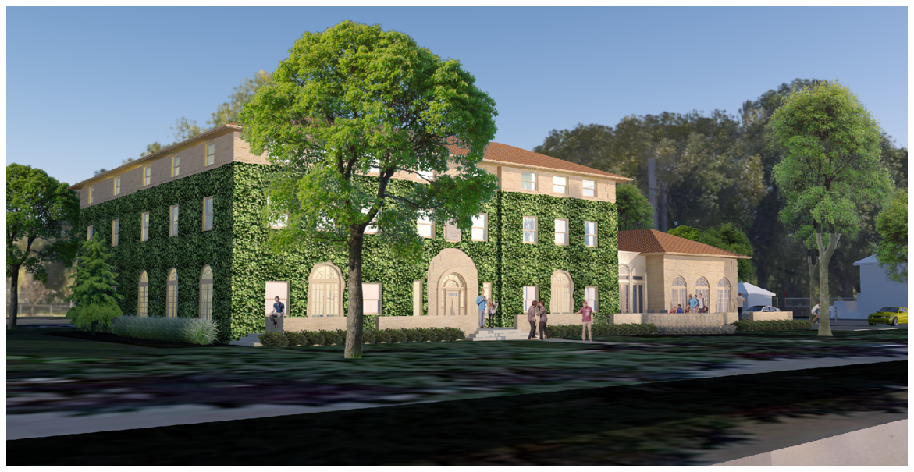

Exterior view from North Russell Street. New addition is shown at right side.

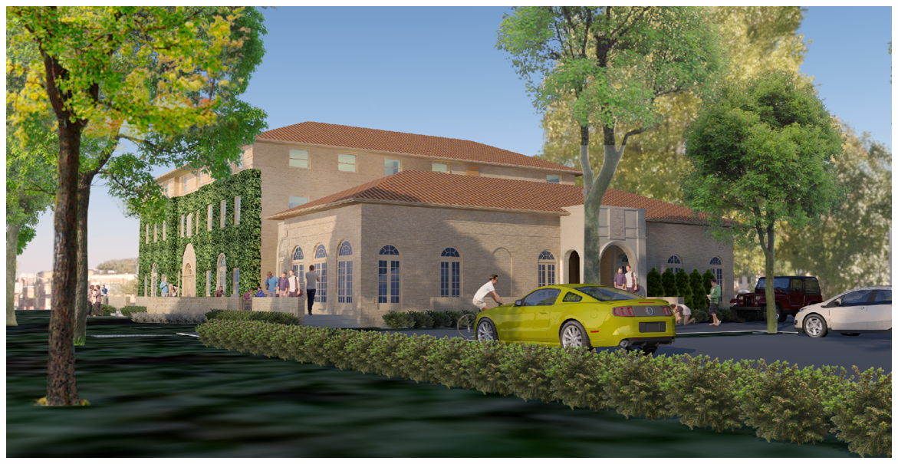

Existing structure (ivy-covered, at left) and new addition and parking lot.

First Floor: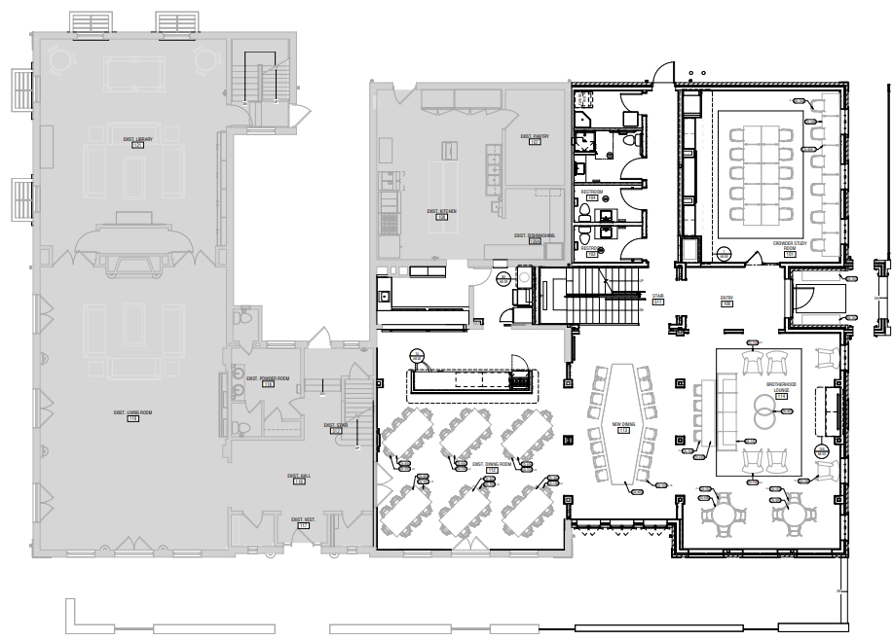

Lower Level:

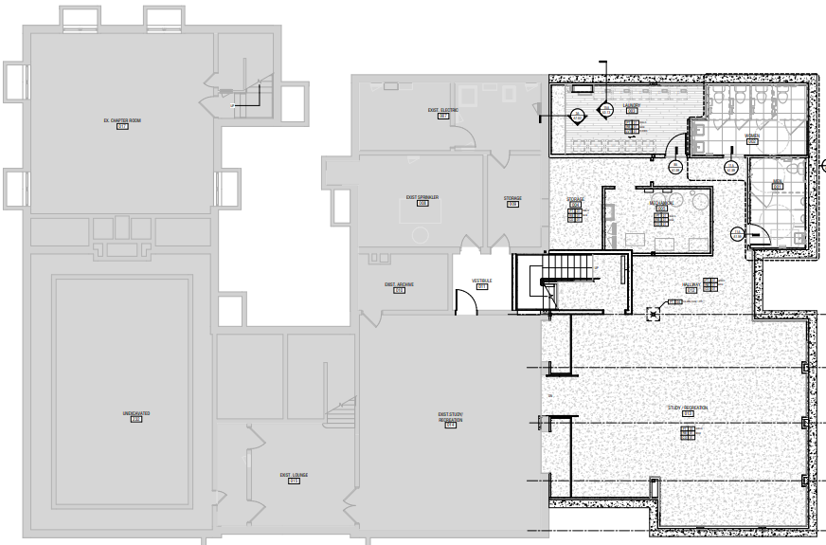

# Additional Good News!

We are pleased to announce that the Purdue University trustees have approved the sale to the Lambda Iota Graduate Corporation, of the last lot on the West side of the 600 block. This means we own the entire Ludy house and west half of the 600 block.

Our graduate brothers have helped fund the purchase from the University, and we are especially grateful to William R. Miller (Indiana ’61), who has championed and promoted this project to the house corporation.  He has also made a generous financial investment in the purchase that he hopes will encourage additional graduate support.  The entire structure will be renovated and restored to become a study center for undergraduates, and a gathering place for returning graduates.  In Bill’s honor we are excited to rename the Ludy house to the “Bill Miller House”!

Our original plans did not include acquiring the former Ludy house. However, during the pandemic, we learned that it provided additional high-quality study space. We, therefore made some modest changes to our parking configuration to the south of the proposed addition to allow us to keep the house. No undergraduates will live in the house, but with only cosmetic work and the addition of furniture we will gain 1,500 square feet of study/meeting space.

# Recognition Opportunities

All graduates, parents, and friends who contribute $1,000 or more to either **Phase 1 or** **Phase 2** will have their name included on a plaque in the new addition.

For individuals or families who are interested in recognizing their special relationship with Phi Gamma Delta, there is the possibility of naming an area or room of the house in your name, or in memory of another brother or family member. Or a pledge class may choose to raise funds to name a room or area of the house, either in the name of the class or in memory or honor of one of its class members. At the time a gift is made, you will be invited to discuss the best way to recognize your generosity if you so desire.

We invite you to join your brothers in supporting this worthwhile endeavor. Several graduate members have dedicated their personal time, talent, and treasure to create a long-range plan that will ensure that our Lambda Iota Chapter of Phi Gamma Delta remains a leading fraternity at Purdue University. Help ensure the future of OUR Chapter!

# How to Make a Gift

To allow for meaningful participation, gifts to this project may be paid over as much as a 5-year period. Here are the ways that you can support Lambda Iota today (and in the future):

◻ **If your gift is less than $5,000**, send your check payable to:

Lambda Iota Graduate Corporation

c/o Lori L. Clark

Girardot Strauch & Company

P.O. Box 1497

Lafayette, IN 47902

(765) 423-5313

◻ **If your gift is $5,000 or more** and tax deductibility of your gift is not important, simply send it to the Lambda Iota Graduate Corporation as indicated above. This will be a tremendous help by making your gift immediately available for use in this important project.

◻  **If your gift is $5,000 or more** and you would like for a portion of it to be tax deductible:

First, direct 70% of your gift to the Lambda Iota Graduate Corporation as indicated above.

Second, direct 30% of your gift to the Phi Gamma Delta Educational Foundation in either of two ways:

* 1. Mail a check payable to “Phi Gamma Delta Educational Foundation” with “Lambda Iota CHEF Fund” in the memo field to:

Phi Gamma Delta Educational Foundation, Inc.

Attn: Ben Robinson, Executive Director

PO Box 4599

Lexington, KY 40544-4599

* 1. To gift appreciated securities, provide the following to your broker:

DTC Number 0062

For the benefit of Phi Gamma Delta Educational Foundation Inc

Brokerage Number 84578989

It is vital that you provide your name, the stock name and number of shares being transferred, so that your gift can be credited to the Lambda Iota CHEF Fund. Please notify Ben Robinson, Executive Director (859-255-1848, ext 133; [brobinson@phigam.org](mailto:brobinson@phigam.org)).

If your pledge is to be paid over multiple years, there could be an advantage to paying the full portion of the gift to the Educational Foundation in a single tax year. Please consult your tax advisor for details.

◻ **Gifts from an IRA** - Individuals aged 70½ or older can make gifts up to $100,000 per year, using funds transferred directly to the Phi Gamma Delta Foundation from their IRA without paying taxes on the distributions. The transfer generates neither taxable income nor a tax deduction, so you will benefit even if you do not itemize your tax deductions. In addition, your IRA gift can count toward your minimum required distribution in the year that the gift is made, as long as you have not received your full distribution for the same year. To learn more, contact Bob Swinehart (219-395-0408; reswinehart@comcast.net).

◻ **Corporate Matching Gifts** - If your company has a matching gift program, there are some important factors to consider. To ensure that your gift will be eligible for the complete match, please contact Bob Swinehart (219-395-0408; reswinehart@comcast.net) for details.

◻ **Estate Gifts** - Would you consider including Lambda Iota in your estate plans? Though the campaign is focused on current cash gifts, estate gifts will be accepted and included in our campaign totals. Estate gifts may not, however, be used to name a room or portion of the Chapter house until the gift is actually received from the donor’s estate. But even if it’s not part of this project, when the time is right for you to create or revise your estate plans, please consider including Lambda Iota among your charitable interests.

# Frequently Asked Questions

**Are naming opportunities available?** Yes, there are naming opportunities available for certain gifts to this campaign. These include the possibility of naming a room of the house in your name or in memory/honor of another brother or family member. If that is of interest, please contact Bob Swinehart (reswinehart@comcast.net) or a member of the campaign steering committee.

**Can a company’s matching gifts be included?** Gifts to the Phi Gamma Delta Educational Foundation may qualify for a company match, depending on your company’s matching gift guidelines. If your company matches gifts, just let us know and we’ll be glad to help. A company match will count towards naming rights, if desired.

**Can I donate appreciated securities?** Yes. You can avoid capital gains taxes on securities you donate to the Educational Foundation, and you can deduct the full market value of the gift from your taxes in the year you make the gift. Appreciated securities may also be contributed to the Lambda Iota Graduate Corporation, but such gifts are not tax-deductible and may result in capital gains tax to the donor. Please consult your tax professional for tax considerations. For additional information on how to contribute appreciated securities, contact Bob Swinehart (reswinehart@comcast.net).

**How can I learn more about this project?** Any member of the campaign steering committee will be happy to help. The graduates who have volunteered their time to lead this effort are:

Charles Armstrong, 1964

John Barbee, 1998

Christopher Burke, 1977

Martin Burke, 1985

Jeffrey Cooke, 1967

Michael Dilts, 1981

Drew Donovan, 1981

Jack Goris, 1976

James Hill, 1994

Robert Hill, 2006

William Kassling, 1966

Robert Martin, 1962

William Miller, 1963 - Indiana

James Neff, 1986

Roger Parkhurst, 1965

Martin Pickett 1975

Robert Swinehart, 1965

# 

# YOU ARE NEEDED!

Our chapter was built on a legacy provided by others. Today, you have a chance to participate in the next phase of our chapter’s growth and success by joining other graduates as we continue the legacy by building the future. Please join us in ensuring that this tradition endures and that Lambda Iota Chapter remains an active and steadfast supporter of academic pursuits, leadership enhancement, and Greek life at Purdue University for generations to come.